# Manual of Plugin: SearchMneuOptions

-- Power by DHM(huimingdeng).

### Search Menu Options Page :

1. Click on the "A" icon to download the current usage document.

点击位置“A”可以下载本说明文档。

2. Click the add button in position "B" to add a single Menu Item. For example, fill in the menu information in figure 2. Click save to publish to the website. To see the effect, you need to search for products that apply new menu items.

点击位置“B”可以添加单个的菜单项。例如图2：填写菜单信息，保存发布到网站中。查看效果则需要搜索应用新增菜单项的产品。

3. Click on the “C” icon to modify the menu item information.

点击位置“C”可以修改当前这一条菜单项信息。

4. Click the "D" font icon to delete the corresponding menu item information.

点击位置"D"可以删除对应的这一条菜单项的信息。

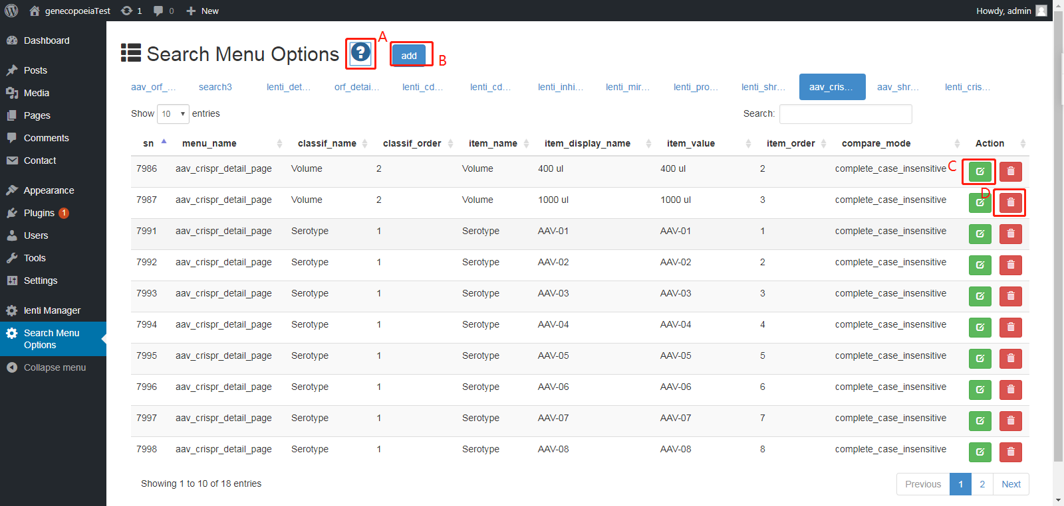

**Picture One** (图1)

5. Figure 2. Fill in the value of the existing "menu name" in position E to represent the existing menu subitem; if the new menu item is, the search page and the search results page must exist.

图2位置E填写现有的"menu_name"的值则表示现有菜单子项，若是新的菜单项则必须搜索页和搜索结果页必须存在。

6. In figure 2, F fills in the judgement value in the function filter_compare in the file httpdocs/includes/common_function.php .

图2位置F填写文件 httpdocs/includes/common_function.php 中函数 filter_compare 中的判断值，或者添加新的值则函数要添加对应的判断方式。

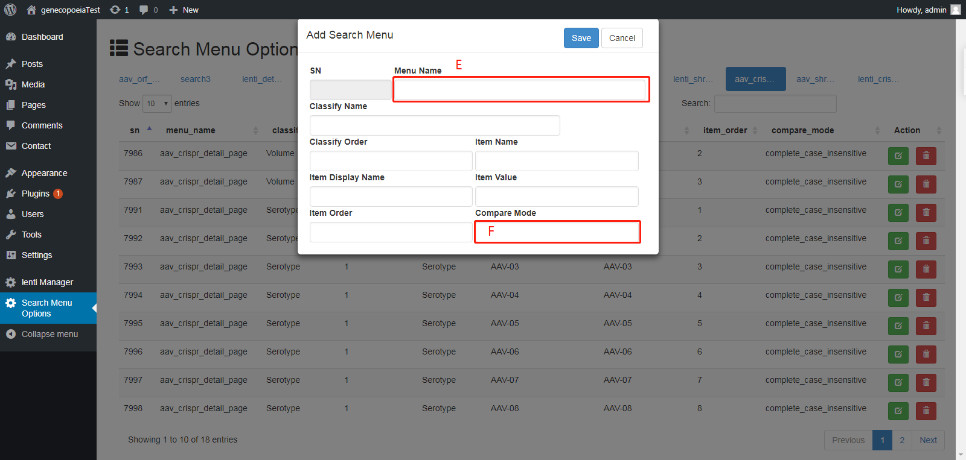

**Picture Two** (图2)

7. Reference function

参考函数

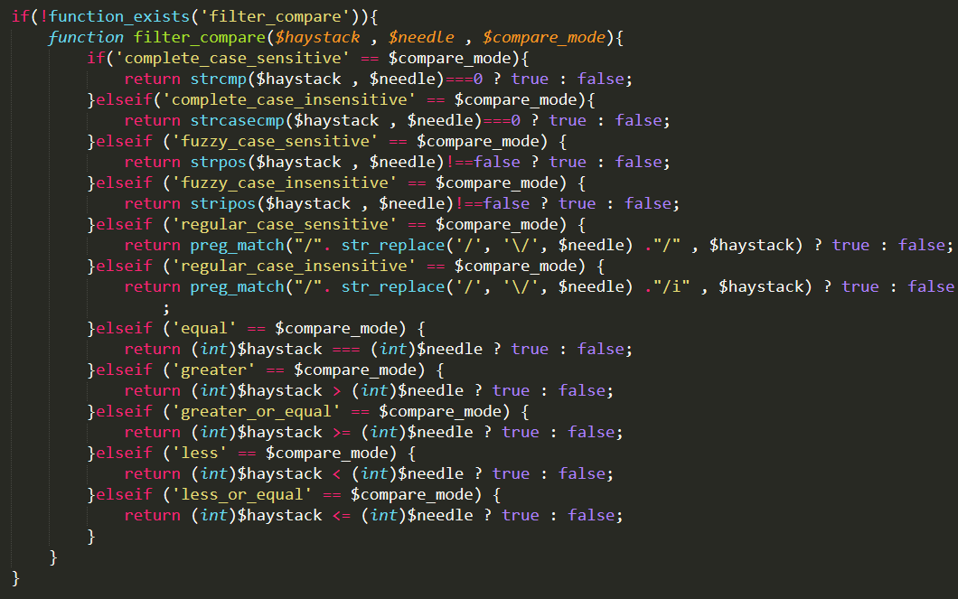

**Picture Three** (图 3)